Informed Consent – Gastrectomy
Department of Surgery, Nagasaki University Graduate School of Biomedical Sciences

Important things you need to know
Patient choice is an important part of your care. You have the right to change your mind as it is safe and practical to do so ). We will also only carry out the procedure on your consent form, a further procedure is needed in order to save your life or prevent serious harm to your health. However, there may be procedures you do not with us to carry out and these can be recorded on the consent form.

The stomach
This is an organ in the upper abdomen that stores and helps digest food and drink.

Cancer of the stomach
This is a cancer that grows in the stomach wall and may cause pain, vomiting and/or anemia and can lead to weight loss. It is amongst the 5 commonest cancers in Japan.
Removing the cancer by surgery may cure it.

About gastrectomy
To diagnose this cancer we use endoscopy to look down into the stomach directly. We also arrange an abdominal CT scan, and upper gastrointestinal series.
After these tests are completed we can advise you on the need for an operation to remove the cancer. This operation is called either a “total gastrectomy” (removing all the stomach) or a “subtotal gastrectomy” (removing about 2/3 of the stomach).
Wether you need total or subtotal gastrectomy depends on the condition of your cancer, mainly the cancer location in the stomach, and the status of lymph node metastasis.
The object of the operation is to remove the cancer with surrounding tissue including lymph nodes. Resection of the spleen may be needed for proper lymph node dissection.
After gastrectomy, the lower esophagus or the remnant stomach is then joined to the bowel so that the food to pass through the bowels. The diagram below may help you understand what is done in this procedure.
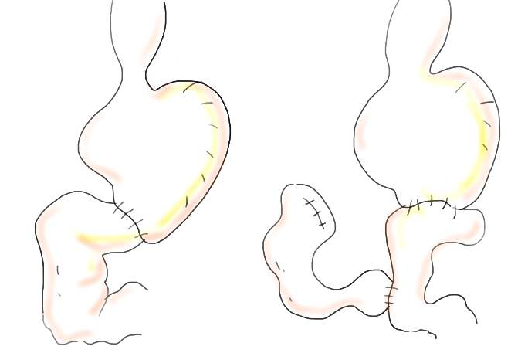
(Left) Billroth-I reconstruction after subtotal gastrectomy
(Right) Roux-en-Y reconstruction after subtotal gastrectomy
There are different ways of perfoming a gastrectomy: open or laparoscopic gastrectomy.
Open gastrectomy needs an incision in the upper part of the abdomen to access the stomach area. In contract, laparoscopic gastrectomy needs 5 to 6 small incisions for insertion of the laparoscopic foreceps and laparoscope into the abdominal cavity.
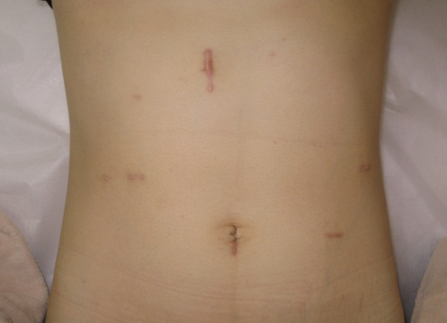

After the procedure
Once your surgery is completed you will usually be transferred to the recovery room where you will be looked after by trained nurses. The nurses will monitor your heart rate, blood pressure and oxygen levels.

Drain tube
You may have some tubes in your abdomen. The purpose of this is to prevent the accumulation of body fluids that may lead to infection. Usually drain tubes are kept in for three to seven days and removed at bed side.

Getting back on your feet
We will help you to become mobile as soon as possible after the operation. A team of physiotherapists will encourage you to achieve this.

Eating and drinking
Immediately after the operation you will only have very small amounts of water to keep your mouth wet. The next day of the operation we allow you to start drinking normally again. After about 3 days we would expect you to start eating if the recovery has progressed normally. Once you start eating your dietician will advise you of the appropriate consistency of foods and fluids you should be eating and drinking during this time.
After gastrectomy, you will need to change your eating habits. It will be necessary to have much smaller meals very often and not 3 large meals. This is because a large volume of food is likely to make you feel sick. Your dietician will help you by tailoring the advice about portion sizes and the number of meals you require each day. It helps if you sit up or have a walk after every meal as this will aid the movement of food down into the rest of the bowels. You may also need to have nutritional supplements to help prevent any further weight loss or to help maintain your nutritional status in the first few months following surgery.

Leaving hospital
On average patients stay for a period of 14 to 21 days after the operation. If there are complications then this stay may be prolonged.

Resuming normal activities including work
Most people who have had this procedure can resume normal activities six to eight weeks after leaving hospital. You might need to wait a little longer before resuming more vigorous activity.

Alternative procedures that are available
Currently, the only known way of curing stomach cancer includes this type of surgery. Often other treatments, such as chemotherapy, are combined with surgery.
Cancer involving only the mucosa can sometimes be safely removed by an endoscopy under sedation.

Significant, unavoidable of frequently occurring risks of this procedure

Anastomotic leak
This is the most important, serious complication following a total gastrectomy. Fortunately it is rare. Where the gastro-intestinal tract is rejoined after an operation is called the anastomosis. Surgeons take great care and time in constructing a water tight anastomosis that will not leak. However, in rare cases the anastomosis does not remain water tight. This is often because of a poor blood supply rather than any particular problem with the surgery. If a leak does occur, there is a significant risk of infection and you will require antibiotics and possibly a fine drain tube to be inserted (under local anesthetic) next to the anastomosis to get rid of any excess fluid or infection. With an anastomotic leak you usually are not permitted to take anything by mouth as this may worsen the leak. Most anastomotic leaks are very small (pin head size) and resolve spontaneously after five to seven days, without too many problems. In rare cases, patients can become very ill and need to be transferred back to the intensive care unit or require further surgery.

Damage to the pancreas
Very rarely, damage to the pancreas can occur that results from the removal of the lymph nodes adjacent to the pancreas. Pancreatic juice is one of the strongest digestive excretion and if it leaks out into abdominal cavity, there is a risk to injure the surrounding tissue and vessels. With pancreas fistula you usually are not permitted to take anything by mouth for keeping the rest of the pancreas. In rare cases, abdominal abscess could be developed and surgical intervention is needed.

Chest infection
Major surgery carries with it a risk of developing an infection in the lungs or pneumonia and it is quite common following this procedure. This is usually because you are a little immobile and not breathing deeply following surgery, resulting in the lower part of the lungs becoming stagnant. Chest infections are treated with antibiotics and physiotherapy. It is very important that you get up and moving as soon as possible and work closely with the nursing staff or physiotherapist in making sure you are taking regular, deep breaths. You will be given deep breathing exercises to undertake. The risk of developing a chest infection is greatly increased if you smoke cigarettes (particularly within three months of surgery).

Pleural effusion
Fluid that collects between the lung and the chest wall is called a pleural effusion. This sometimes develops following surgery and is in many ways the body’s normal reaction to surgery. If fluid does, however, accumulate as a pleural effusion it may need to be specifically drained. This is usually done under local anaesthetic either on the ward or by our colleagues in the X ray department.

Complications relating to the heart
Major surgery places considerable stress on the body and there is a small risk of a problem relating to the heart. This may take two forms and varies from very minor to severe. Firstly, the heart may develop an abnormal rhythm (usually beating excessively quickly). You may notice a fluttery feeling (palpitations) in the chest or nothing at all. Usually, simple measures such as balancing the body’s salt concentrations, or administering medications resolve these problems. Secondly and more seriously, suffering a heart attack (damage to the heart muscle) is possible.
Because of these risks you are very closely monitored (including continuously recording the rhythm of the heart) for the first several days following your surgery. Therefore, if a problem arises it can usually be treated early and effectively. The risk of developing a heart problem is increased if you have a history of heart problems, smoke cigarettes (particularly within three months of surgery) or have other risk factors for heart disease.

Deep vein thrombosis (DVT) and pulmonary embolus
All surgery carries varying degrees of risks of thrombosis (clots) in the deep veins of your leg. In the worst case a clot in the leg can break off and travel to the lung (pulmonary embolism). This can significantly impair your breathing. To prevent these problems around the time of your operation, we ask you to wear compression stockings on your legs before and after surgery and also use a special device to massage the calves during the surgery. Moving about as much as you can, including pumping your calf muscles in bed or sitting out of bed as soon as possible reduces the risk of these complications.

Damage to the bowel (intestines)
Any surgery inside the abdominal cavity is associated with a very small risk of damaging other organs, such as the bowel. This is particularly the case if there has been previous surgery with scarring and structures are abnormally stuck to each other. If there is damage to the bowel it can almost always be repaired at the time. If it is not noticed at the time and you later become unwell a second procedure may be required. This is a more serious situation.

Damage to major blood vessels
Any major surgery is associated with a small risk of bleeding from a major blood vessel. This is uncommon; however, if the surgery involves delicate procedures very close to major blood vessels there is a risk. If this were to occur the surgeon would take measures to stop the bleeding and it is possible you would require a blood transfusion.
Damage to the spleen - During the operation, the small blood vessels between the spleen and the upper part of the stomach (fundus) are cut using special instruments that seal the blood vessels before they are divided. Very rarely, damage to the spleen can occur that results in bleeding. Most times, this is not serious and can be controlled simply, however, if the spleen were to sustain a more severe injury the spleen may have to be removed to prevent further bleeding. Removing the spleen normally has few complications. If your spleen is removed you will be given some vaccinations prior to leaving hospital. Additionally, you will be advised to stay on a low dose of preventative antibiotic for at least two years.

Bleeding
This very rarely occurs after any type of operation. Your pulse and blood pressure are closely monitored after your operation as this is the best way of detecting this potential problem. If bleeding is thought to be happening, you may require a further operation to stop it. This can usually be done through the same scar(s) as your first operation. It is possible that you also may require a blood transfusion.

Wound haematoma
Bleeding under the skin can produce a firm swelling of blood clot (haematoma), this may only become apparent several days after the surgery. It is essentially a bruise. This may simply disappear gradually or leak out through the wound without causing any major consequences to you.

Wound infection
This affect your scars. If the wound becomes red, hot, swollen and painful or if it starts to discharge smelly fluid then it may be infected. It is normal for the wounds to be a little sore, red and swollen as this is part of the healing process and represents the body’s natural reaction to surgery. A wound infection can happen after any type of operation. Simple wound infections are easily treated with a short course of antibiotics.

Deep infection
A rarer and more serious problem with infection is where an infection develops inside your tummy or chest cavity. This is often sequel of anastomotic leak or pancreatic fistula. This will often need a CT scan to diagnose, as there may be no obvious signs on the surface of your body. Fortunately, this type of problem will usually settle with antibiotics. Occasionally, it may be necessary to drain off infected fluid. This is most frequently performed under a local anesthetic by our colleagues in the X ray department. In the worst case scenario a further operation is required to correct this problem.

Anastomotic stricture
The join between your esophagus and your small bowel (“anastomosis”) can sometimes narrow down during its healing phase. A stricture is a technical term that simply means a narrowing. This narrowing can cause problems with swallowing, particularly with solid foods. If this happens you might need to have the join stretched gently to make it wider again. This can be done as an outpatient in the endoscopy unit under gentle sedation. Anastomotic strictures often are not apparent for at least several months after surgery and may not occur until one to two years later.

Other complications
We have tried to describe the most common and serious complications that may occur following this surgery. It is not possible to detail every possible complication that may occur following any operation.
If another complication that you have not been warned about occurs, we will treat it as required and inform you as best we can at the time. If there is anything that is unclear or risks that you are particularly concerned about, please ask.

Reference
1. Cambridge University Hospital informed consent form
2. University College London Hospital informed consent form

Consent for Treatment

I understand my condition to be a mass in the stomach and am aware of its risks if untreated. I have read and understand the above explanation of the operation required. My surgeon has answered my questions, and I choose to proceed with surgery.

I understand that every operation may yield unexpected findings. I give the surgeon permission to act on his best judgment in deciding to remove or biopsy tissues that appear to be diseased, understanding that complications may arise from that action.

I understand that while most people receiving a gastrectomy may benefit from this operation, I may not. My condition may not improve, and it may worsen. No absolute guarantee can be made.

Before and after surgery, unless otherwise requested in writing by you, visitors whom you invite to attend the surgery will be informed of the surgical finding, your surgical status, and anticipated recovery issues, for effectiveness of communications. Because of the anesthetic, you may or may not remember these important details

Print NamE__________________________________________________________________________

Signature ______________________________________________ Date _________________

Witness ________________________________________________ Date _________________

Surgeon ________________________________________________Date _________________

Relationship to Patient if Signature of Legal Guardian ________________________________

